Disability Sport Wales Project Officer (insport) Dynamic Welsh Governing Body, Flexible Hours, and the opportunity to transform lives

Disability Sport Wales are looking for an enthusiastic, proactive and passionate project officer to join a team dedicated to supporting the physical activity (including sport) sector in creating an inclusive environment for the whole spectrum of involvement for disabled people.

The Company:
Disability Sport Wales are the lead organisation for disability sport in Wales. We are committed to supporting the Sector Vision of ‘Uniting a proud sporting Nation’, where every (disabled) person is hooked on sport, and we create a Nation of Champions. Disability Sport Wales intends to transform lives, and does this by supporting the provision of genuine choice in opportunity; high quality education, training and learning opportunities; the nurturing of talent, and the fine tuning of elite performers.

The insport project:
The insport project is a series of programmes which seeks to support the wider physical activity (including sport) sector in planning for, delivering, and embedding inclusion within their everyday business. All three programmes (insport NGB (National Governing Body); insport Development, and insport Club) are individual but related toolkits which support organisations to identify and map their inclusive journey.

The Role:
We are looking for a part-time project officer with a strong inclusive philosophy, who is interested in being part of a team who drive transformational change within the physical activity (including sport) sector; ultimately transforming the lives of disabled people. Salary is £24 – 27.5K (pro rata and based on relevant experience) per year
- Flexible working on a weekly, fortnightly or monthly basis
- Great opportunities for continuing professional learning
- Opportunity for wide variety of working environments

The Location:
The Disability Sport Wales Head Office is housed within the Sport Wales National Centre, Sophia Gardens in the heart of Cardiff. Situated next to Bute Park and the SWALEC National Cricket

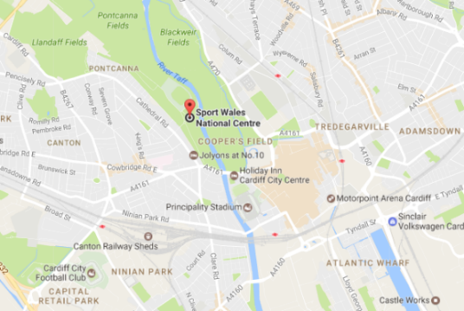
Stadium, with significant free parking, and a sporting buzz – ideally located regardless of how you choose to travel to work. Google maps

Why should you apply for the job?
- Be part of a strong, supportive and proactive team
- Great flexibility in working hours
- Work for an equitable and diverse employer, with strong professional ethics and values
- Opportunity to transform lives and support the delivery of inclusive physical activity (including sport) within Wales
Apply to: Administration Officer, Disability Sport Wales, c/o Sport Wales National Centre, Sophia Gardens, Cardiff, CF11 9SW.
Email: nia.jones@disabilitysportwales.com
Tel: 02920 334924
This post is supported by Sport Wales

