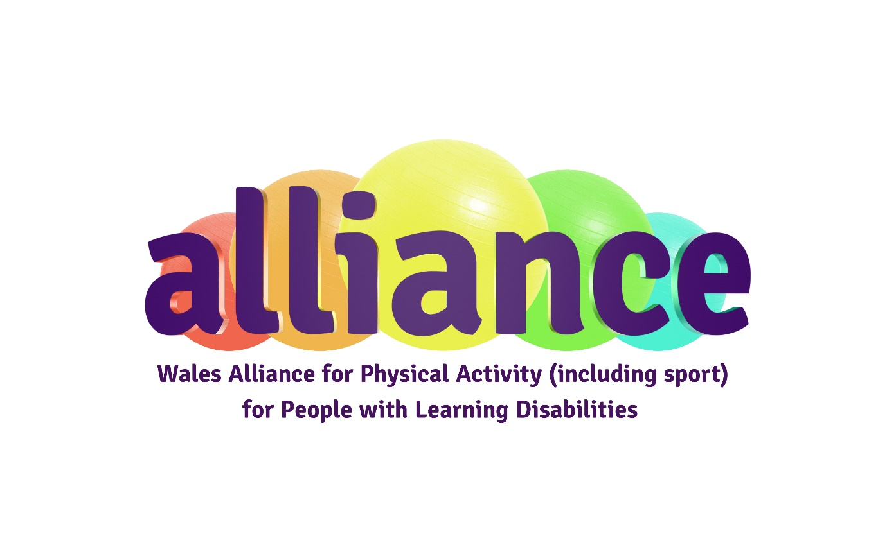
Easy Read
Co-Chair of the Alliance
Application Form 2023-2025

If you would like to be one of the Co-Chairs of the Wales Alliance for Physical Activity (including sport) for People with Learning Disabilities:
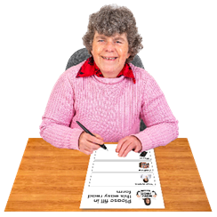
- Fill out this application form
Please send it back to us by email.

 | - Or make your own video  Use a phone with a camera, or a tablet like an iPad, to record your answers to the questions in this application form.

 | If you make a video please email it to us.  It should be no longer than 5 minutes long.
 | Please send us your application form or video by email by 5pm on 14th December 2023 to: Stefano.Antoniazzi@disabilitysportwales.com
 | If you need any support or for more information please email Stefano.Antoniazzi@disabilitysportwales.com with your name and telephone number and we will arrange to contact you for a chat.

Your details
 | Name:
 | Address and postcode:
 | Email address:

 | Telephone Number:
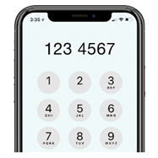 | Mobile Number:
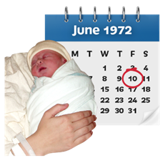 | Date of birth:

Questions
 | - Why do you want to become a co-chair of the Alliance?
 | - Tell us about the skills and experience that you can bring to the role.  Please write about the skills listed in the person specification.
 | - What areas of the work of the Alliance are you interested in and how would you like to help?

References
 | We will ask for 2 references before interview.  Please give us details for 2 people we can contact to ask if you would be good for this role.

 | Referee 1
 | Their name:
 | Their job title:
 | Their email address and telephone number:
 | Relationship to you:

 | Referee 2
 | Their name:
 | Their job title:
 | Their email address and telephone number:
 | Relationship to you:

Declaration
 | Please make sure you fill this part in.  I confirm that I am suitable to be a co-Chair, of the Alliance.
 | Signed:
 | Print Name:
 | Date:

