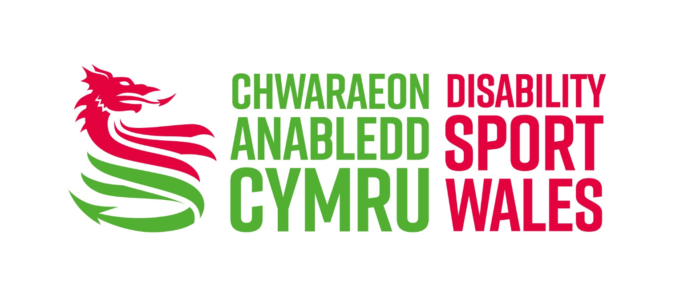

Equity and Diversity Policy

2024

Statement of Intent

1.1 The Federation of Disability Sport Wales (FDSW, but referred to as Disability Sport Wales (DSW) throughout) is fully committed to ensuring that no employee, volunteer, official, coach, tutor, member, athlete, or job applicant receives less favourable treatment on the grounds of disability or impairment; age; gender identity and assignment; sex; ethnic origin; nationality; parental, marital, or civil partner status; pregnancy; religious belief; class, social or financial background; sexual preference; Welsh language; or political belief.

1.2 DSW will ensure that there is open access to all those who wish to participate, gain employment, or take up a non-participatory role in all aspects of physical activity, including sport, and that they are treated without bias, with respect, and with parity.

1.3 DSW are committed to ensuring equity is at the heart of all planning, delivery, or policy development; and to work with other partner organisations to stay current with best practice.

1.4 Fair treatment, provision of opportunity and intent is regarded by the DSW NOT as a privilege for some, but as a right for all.

  - DSW is committed to ensuring that its employees, members, participants, and volunteers are able to conduct their activities free from discrimination, harassment or intimidation.

  - DSW are committed to supporting and creating diversity and have a ‘Diversity Strategy’ which outlines the approach the organisation takes to ensuring that there is appropriate representation from communities sharing protected characteristics, the positive action, which is being taken to support this commitment, and highlights the link between DSW’s approach to achieving equality, and the practices it uses.

2. Purpose of the Policy

2.1 Ensure clarity that DSW will not tolerate any discrimination or other unfair or inequitable treatment, whether intentional or unintentional, direct, or indirect, against its employees, members, athletes, or others it deploys. The DSW will treat any discrimination against, demonstration of a lack of respect for, or failure to behave in an inclusive way, seriously and in accordance with its disciplinary processes.

3. Actions

3.1 DSW will produce and maintain an Equity and Diversity Action Plan (EDAP) to ensure the intent of this policy is delivered.

3.2 All areas of the organisation will be affected by this EDAP, which will be incorporated into overall Strategic delivery, itself reviewed and updated on an annual basis.

3.3 DSW recognises that, in some cases, to provide equality, unequal effort is required and, if appropriate, will take positive action to tackle under-representation. This approach is outlined in the ‘DSW Equity and Diversity Framework’ in the Equity and Diversity Objectives.

3.4 DSW are committed to achieving the principles identified in the Equality Standard: A Framework for Sport and will continue to work towards the highest standard as a benchmark of excellence in equitable practice.

3.5 All DSW staff will include equity within their work programme, which is then embedded in their work areas.

3.6 All DSW staff, board, key coaches, and volunteers will receive Equity and Diversity Training as part of their induction and on-going CPD. These training opportunities are communicated to core staff and Board members.

3.7 All programmes, planning and policy is subject to DSW’s Initial Equality Impact Assessment (iEIAs). Through this process it may be that a full Equality Impact Assessment is completed in order to ensure that equitable processes are embedded across the organisation and communities who share protected characteristics are appropriately engaged and involved with (disability) sport.

4. Legal Requirements

4.1 DSW is required by law not to discriminate against its employees and recognises its legal obligations under, and will abide by the requirements included but not limited to the following:

- Equal Pay Act 1970  - Sex Discrimination Act 1975, 1986 and 1999  - Sex Discrimination (Gender Reassignment) Regulations 1999  - Gender Recognition Act 2004  - Civil Partnership Act 2004  - Race Relations Act 1976  - Race Relations (Amendment) Act 2000  - Racial and Religious Hatred Act 2006  - Disability Discrimination Act 1995  - Disability Discrimination Amendment Act 2005  - Rehabilitation of Offenders Act 1974  - Rehabilitation of Offenders Act (Amendment) 2020  - Employment Rights Act 1996 |  | - Work Time Regulations 1998  - National Minimum Wage Act 1998  - Employment Act 2002 (Flexible Working Regulations)  - The Flexible Working Regulations 2014  - Employment Equality (Sexual Orientation) Regulations 2003  - Employment Equality (Religion and Belief) Regulations 2003  - Employment Equality (Age) Regulations 2006  - Protection from Harassment Act 1997  - Human Rights Act 1998  - The Equality Act 2010  - Social Services and Well-being (Wales) Act 2014  - LGBTQ+ Action Plan for Wales

4.2 DSW will seek legal advice each time the policy is reviewed to ensure it continues to comply with all legislative requirements.

5. Discrimination, Harassment and Victimisation

  - Discrimination can take the following forms:
    - Direct Discrimination. This means treating someone less favourably than you would treat others in the same circumstances.
    - Indirect Discrimination. This occurs when a job requirement or condition is applied in the same way to all, which has a disproportionate and detrimental effect on one sector of society, because fewer from that sector can comply with it and the requirement cannot be justified in relation to the job.
    - When decisions are made about an individual, the only personal characteristics considered will be those which, as well as being consistent with relevant legislation, are necessary to the proper performance of the work involved.

  - Harassment is described as inappropriate actions, behaviour, comments or physical contact that is objectionable or causes offence to the recipient.

  - Victimisation is defined as when someone is treated less favourably than others because he/she/they have acted against DSW under one of the relevant Acts/regulations (as previously outlined) or provided information about discrimination, harassment, or inappropriate behaviour.

  - DSW regards discrimination, harassment, or victimisation, as described above, as serious misconduct and any employee, volunteer or member who discriminates against, harasses or victimises any other person will be liable to appropriate disciplinary action.

6. Responsibility, Implementation and Communication

6.1 The following responsibilities will apply:
    - The Board of Directors is responsible for ensuring that this Equity and Diversity Policy is followed and to deal with any actual or potential breaches.
    - The Chief Executive Officer has the overall responsibility for the implementation of the Equity and Diversity Policy (including the Equity and Diversity Action).
    - The Equity and Diversity Lead is designated by the CEO for overall responsibility for maintaining the currency and accuracy of the Equity and Diversity Policy (including the Equity and Diversity Action Plan and the Equity and Diversity framework).
    - ALL employees, volunteers and members have responsibilities to respect, act in accordance and thereby support and promote the spirit and intentions of the policy.

  - The Equity and Diversity Policy will be implemented immediately following Board agreement and, at a corporate level, will result in the following:
    - A copy of this document will be available to all staff (both permanent and contract), members and those deployed by DSW.
    - No job applicant will be placed at a disadvantage by requirements or conditions which are not necessary to the performance of the job, or which constitute unfair discrimination.
    - Positive action will be taken to eliminate barriers which discriminate and DSW managers and staff will work proactively with all agencies to ensure supportive provisions are made in all cases.
    - Ensure that consultants and advisers used by DSW can demonstrate their commitment to the principles and practice of Equity and that they abide by this policy.

  - The Equity and Diversity Policy will be communicated in the following ways:
    - It will be part of the staff handbook and reference will be made to it in any codes of conduct.
    - It will be covered in all staff and volunteer induction training
    - All members and service users will be made aware of the policy’s existence
    - It will be available on the Website and in alternative formats.
    - At time of review, a mechanism will be put in place to allow all staff, members and volunteers to be part of the process.

7. Monitoring and Evaluation

  - Once approved, the policy will apply for 3 years before a formal review takes place, unless any proposal to the Board, or legislation change, requires an interim review and/or amendment.

  - The Equity and Diversity Action Plan, created to ensure the intent of the policy is delivered, will be reviewed by the CEO, the Chair of the Governance Committee, and the member of staff with the responsibility for its implementation, on an annual basis.

  - As part of the overall Strategic Plan, the Equity and Diversity Action Plan will be reviewed by the Board on an annual basis.

  - On an annual basis, statistical information will be produced for the Board, and will be published internally and externally, to show the impact of practice supported by this policy.

8. Disciplinary and Grievance Procedures

  - To safeguard individual rights under the policy, an employee, volunteer or member who believes he/she/they have experienced inequitable treatment within the scope of the policy may raise the matter through the appropriate grievance procedure.

  - Appropriate disciplinary action will be taken against any employee, volunteer or member who violates the DSW Equity and Diversity Policy.

8.3 An individual may raise any grievance and no employee, volunteer or member will be penalised for doing so unless it is untrue and not made in good faith.

8.4 As with all grievance procedures, the final point of appeal relating to this policy is the Board appeals committee.

