Wales Deaf Sport
Recruitment Pack - Chair and Treasurer
Contents:
- Why Give Your Time to Wales Deaf Sport?
- Trustee Responsibilities
- Wales Deaf Sport Strategy
- Wales Deaf Sport Structure
- Wales Deaf Sport Chair Responsibilities and Criteria
- Wales Deaf Sport Treasurer Responsibilities and Criteria
- How to Apply
- Application Timeline
Wales Deaf Sport Vision towards 2030
An inclusion nation where deaf people are active, living healthier, happier, more confident and connected lives.
Below are the values embodied by Wales Deaf Sport:
- Driven by Inclusion Making sure our partners provide deaf people with equality of opportunity.
- We Are Resilient We never give up on our vision of a more equal sporting Wales.
- Hwyl We are a family that is motivated, energetic and supports each other through both good and difficult times.
- We Embrace Innovation We are forward thinking, solutions focused, and always striving to improve.
- We Are Progressive We want to lead from the front, with integrity in an open, and collaborative manner.
Why Give Your Time to Wales Deaf Sport?
Wales Deaf Sport is committed to ensure that its trustees are representative of the deaf sports community, and that the skills, knowledge and experience of the committee are diverse. It is important for the Wales Deaf Sport committee to have a balance between lived experience and specific skills to ensure that the needs of the deaf sports community are met.
We are recruiting for a Chair and a Treasurer (two roles) to join Wales Deaf Sport.
It is preferred that these positions are filled by people connected to the deaf community whether that is a deaf person, someone with deaf family, or someone who has experience working and communicating with deaf people.

Trustee Responsibilities
Trustees of Wales Deaf Sport are responsible for the overall governance of the charity. As a trustee, you will be expected to:
- Attend all Wales Deaf Sport meetings (including the AGM) which:
  - happen once every three months
  - are 2 hours long
  - take place via Zoom or Microsoft Teams
  - take place in English with BSL interpreters for accessible communication
- Represent Wales Deaf Sport at events
  - Including but not limited to WDS member sports events
- Undertake the six main duties of a trustee
- Ensure the Charity is carrying out its purpose for the public benefit
- Comply with the Charity’s governing documents and law
- Act in the Charity’s best interests
- Manage the Charity’s resources responsibly
- Act with reasonable care and skill
- Ensure that the Charity is accountable
Click here for further details (The Essential Trustee, PDF)

Wales Deaf Sport Strategy
The Wales Deaf Sport Strategy was launched in 2022 and has six key focuses to improve the infrastructure and legacy of deaf sport in Wales. The full strategy can be found here (BSL and Welsh versions available on the Wales Deaf Sport website)
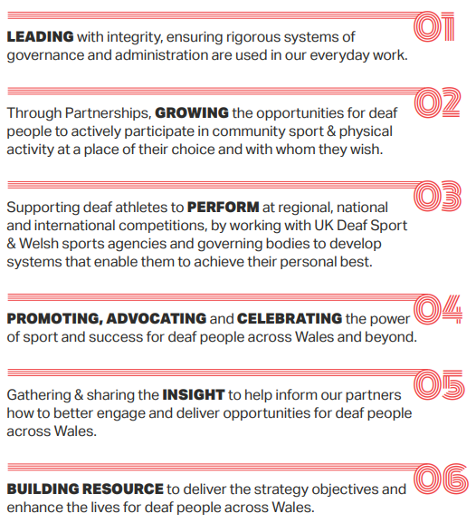

Wales Deaf Sport Structure
Wales Deaf Sport is a member of the Federation of Disability Sport Wales. The Chair of WDS (or otherwise decided) will be responsible for representing WDS at the Disability Sport Wales AGM. Within Disability Sport Wales, there is a Deaf Sport Senior Officer. Wales Deaf Sport also has Charity Commission listed Trustees and an Honorary President (Glyn Rosser MBE) and Vice Presidents (Donald Simms and Philip Donovan). It is important and necessary for the WDS Trustees and wider workforce to work with the Disability Sport Wales team to deliver the WDS Strategy and create a thriving deaf sport infrastructure in Wales.
Wales Deaf Sport Chair Responsibilities and Criteria
As Chair of Wales Deaf Sport, here are some expectations and responsibilities.
- Lead and chair Wales Deaf Sport meetings
- Ensure that the Trustees function effectively, meetings are led inclusively, and the committee carry out their duties.
- Ensure delivery of the Wales Deaf Sport strategy leading towards 2030
- Foster a good working relationship with Disability Sport Wales and Deaf Sport Senior Officer
- Foster strong relationships with Wales Deaf Sport members
- Identify appropriate funding and grants relevant to Wales Deaf Sport
- Act as an ambassador for Wales Deaf Sport, representing its mission and values to external stakeholders

Wales Deaf Sport Treasurer Responsibilities and Criteria
As Treasurer of Wales Deaf Sport, here are some expectations and responsibilities.
- Manage the financial accounts for Wales Deaf Sport
- Produce financial reports for Wales Deaf Sport meetings
- Identify appropriate funding pots and grants
- Organise and distribute income (funding and grants) appropriately
- Ensure compliance with Charity Commission reporting requirements
How to Apply
Send through an Expression of Interest which needs to include:
- The role you are interested in and why
- Current CV
- Letter or video (BSL or English) covering how your skills, knowledge and experience would make you suitable as Chair or Treasurer of Wales Deaf Sport
Please send to Libby Steele (Deaf Sport Senior Officer, Disability Sport Wales)
Via email: libby.steele@disabilitysportwales.com
Or WhatsApp: 07863142970
Application Timeline
Application deadline: Wednesday 22nd July
If you are shortlisted for interview, you will be contacted on Thursday 30th July
Interviews: 5th & 10th August. These will be virtual interviews and will include a panel of no more than three people. The Zoom link will be emailed when you are invited to the interview.
Applicants who have not been successful at any stage of the process will be notified in writing (or other appropriate and accessible format).

