
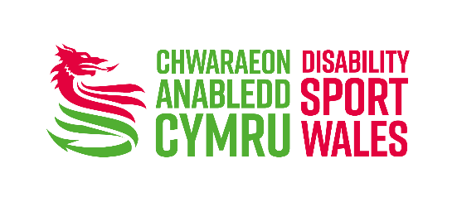

Disability Sport Wales Awards 2022
Athlete of the Year Nomination Form
This nomination form is only to be used to nominate the Athlete of the Year. Please send completed forms to awardsnominations@disabilitysportwales.com
This award recognises the outstanding achievement of an Athlete of the Year during 2021/22. This category is restricted to athletes who have competed at a Paralympic, World, Deaflympic, Special Olympic, INAS, European or Commonwealth Games during 2021 or a season ending in March 2022.
Please send completed
Nomination Forms to: awardsnominations@disabilitysportwales.com
Video Nominations to: WhatsApp 07458 031 645
Audio Nomination: awardsnominations@disabilitysportwales.com OR WhatsApp 07458 031 645

What we’re looking for:
- Evidence of achievements between 1st January 2021 – 31st March 2022
- Medal success at International level
- Commitment to their sport outside of their medal success
- Evidence from their Welsh/UK National Governing Body of their performance within their sport/s.

Process for selection from total nominees:
- Internal Panel will shortlist to six nominees
- Six nominees will be referred for consideration to the DSW Awards Panel, who will select a category winner and two other finalists
- Should your application be shortlisted, the nominator may be required to provide further detail to the nomination at the award panel which will take place on 25th April 2022.
- The Winner will be announced at the DSW Virtual Awards on Friday 24th June 2022

Nominee Details
Full Name
Address
Post Code |  |  |  | Contact Number
Email Address
Date of Birth |  |  |  | Sport(s)
Number of years active as an athlete
Local Team / Squad
Regional Team / Squad
National Team / Squad
Any awards / recognition received during the past 12 months. Please give details.
Nominator Details
Full Name
Post Code |  |  | Contact Number
Email Address
Relationship to Nominee

Achievements
In 100 – 400 words please detail the key achievements of the nominee in 2022 or a season ending in March 2022 (e.g. 1st January 2021 – 31st March 2022).

Please note: What have been the nominee’s best achievements during the past 12 months? (please refer to guidance notes)

You may use bullet points, and facts and figures should be included where possible. List examples of competitions, medals, personal/season’s best, awards

Impact
In 100 – 400 words please tell us what impact the nominee in 2021 or a season ending March 2022.
Dedication
On average, how many hours does this nominee train each week?

Additional Supporting Information
You may use this space to tell us in no more than 400 words why this athlete should win the award.

Declaration
I confirm that the details given in this nomination are accurate.
Name |  |  | Date
If nominee is under 18 parental consent is required
Name of Parent or Guardian
Signature |  |  | Date
Contact Number

- Remember to fill in all the required fields for your chosen category nomination. Only complete applications will be considered.
- All nominations will go through a shortlisting process. Shortlisted nominations will be considered by a Disability Sport Wales Awards panel.
- Finalists will be selected by the Disability Sport Wales Awards panel and provided with information about when and how the winners for each category will be announced at ****.
Send your completed
Nomination Forms to: awardsnominations@disabilitysportwales.com
Video Nominations to: WhatsApp 07458 031 645
Audio Nomination: awardsnominations@disabilitysportwales.com OR WhatsApp 07458 031 645

Full terms and conditions and category descriptions available at www.disabilitysportwales.com

