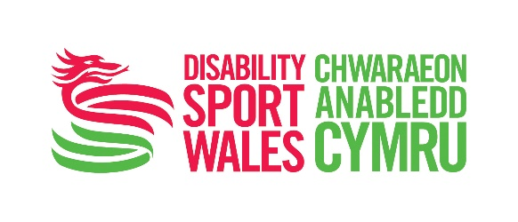


Disability Sport Wales Awards 2016
Transforming Lives Award Nomination Form
This award is to celebrate the contribution and achievements of the nominee between 1st September 2015 and 30th September 2016.
Please send completed forms to awardsnominations@disabilitysportwales.com
—
Nominator Details
Full Name
Address
Post Code |  |  | Contact Number
Email Address
Relationship to Nominee
_
Nominee Details
Continued overleaf
Full Name
Address
Post Code |  |  |  |  | Contact Number
Email Address
Date of Birth |  |  |  |  | Sport(s)
Club or Organisation
Current Coaching / Volunteering Role (if applicable)
Number of years active as a coach / volunteer (if applicable)?
Level of athletes coached (if nominating a coach) e.g. school, community, regional, international.
Any awards / recognition received during the individual’s coaching / volunteering work. Please give details.
_
The next section is your opportunity to explain why you feel the nominated person is worthy of the Transforming Lives award. You might like to include details of when they have inspired others, made a difference, or gone the extra mile in their role.
–
Achievements
Continued overleaf
In 100 – 400 words please detail the key achievements of the nominee in the 12 months from 1st September 2015 - 30th September 2016. How have they ‘transformed lives’?

Please note: What have been the nominee’s best achievements during the past 12 months? (please refer to guidance notes)

You may use bullet points, and facts and figures should be included where possible.
_

Impact
Continued overleaf
In 100 – 400 words please tell us what impact the nominee has made in the 12 months from 1st September 2015 - 30th September 2016.
_
Qualifications, Training and Development
Please list the nominee’s qualifications and any evidence of how they have developed their skills and kept up to date with personal development
_
Dedication
On average, how many hours does this nominee spend each week ‘Transforming Lives’ through sport?
Please indicate if their role is part time or full time | ☐ Full Time ☐ Part Time
_
Additional Supporting Information
Continued overleaf
You may use this space to tell us in no more than 400 words why this individual should win the ‘Transforming Lives’ award.
_

Declaration
I confirm that the details given in this nomination are accurate.
Name |  |  | Date
If nominee is under 18 parental consent is required
Name of Parent or Guardian
Signature |  |  | Date
Contact Number

- Remember to fill in all the required fields for your chosen category nomination. Only complete applications will be considered. All nominations will go through a shortlisting process. Shortlisted nominations will be considered by a Disability Sport Wales Awards panel. Finalists will be selected by the Disability Sport Wales Awards panel and winners will be announced at the Disability Sport Wales Celebration Evening on ceremony on 27th January 2017.
- Send your completed nomination form to awardsnominations@disabilitysportwales.com OR to Disability Sport Wales, Sport Wales National Centre, Sophia Gardens, Cardiff CF11 9SW.
- Full terms and conditions and category descriptions available at www.disabilitysportwales.com

