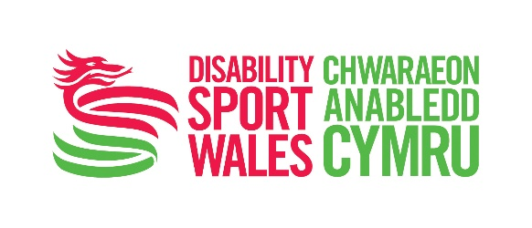


Disability Sport Wales Awards 2016
Lifetime Achievement Award Nomination Form
Please send completed forms to awardsnominations@disabilitysportwales.com
—
Nominator Details
Full Name
Address
Post Code |  |  | Contact Number
Email Address
Relationship to Nominee
_
Nominee Details
Continued overleaf
Full Name
Address
Post Code |  |  |  | Contact Number
Email Address
Date of Birth |  |  |  | Sport(s)
Club or Organisation
Current Coaching / Volunteering Role (if applicable)
Number of years active as a coach / volunteer (if applicable)?
Level of athletes coached (if nominating a coach) e.g. school, community, regional, international.
Any awards / recognition received during the individual’s career in sport. Please give details.
_
The next section is your opportunity to explain why you feel the nominated person is worthy of the Lifetime Achievement award. You might like to include details of when they have inspired others, made a difference, or gone the extra mile in their role.
–
Achievements
Continued overleaf
In 100 – 400 words please detail the key achievements of the nominee detailing how they have contributed to disability sport in Wales?

Please note: List the nominee’s achievements.
You may use bullet points, and facts and figures should be included where possible.

Impact
Continued overleaf
In 100 – 400 words please tell us what impact the nominee has made on disability sport in Wales, either through coaching, administration, performing or volunteering.
_
Additional Supporting Information
Continued overleaf
You may use this space to tell us in no more than 400 words why this individual should win the Disability Sport Wales Lifetime Achievement award.
_
Declaration
I confirm that the details given in this nomination are accurate.
Name |  |  | Date
If nominee is under 18 parental consent is required
Name of Parent or Guardian
Signature |  |  | Date
Contact Number

- Remember to fill in all the required fields for your chosen category nomination. Only complete applications will be considered. All nominations will go through a shortlisting process. Shortlisted nominations will be considered by a Disability Sport Wales Awards panel. Finalists will be selected by the Disability Sport Wales Awards panel and winners will be announced at the Disability Sport Wales Celebration Evening on ceremony on 27th January 2017.
- Send your completed nomination form to awardsnominations@disabilitysportwales.com OR to Disability Sport Wales, Sport Wales National Centre, Sophia Gardens, Cardiff CF11 9SW.
- Full terms and conditions and category descriptions available at www.disabilitysportwales.com

