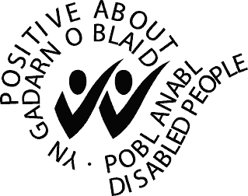

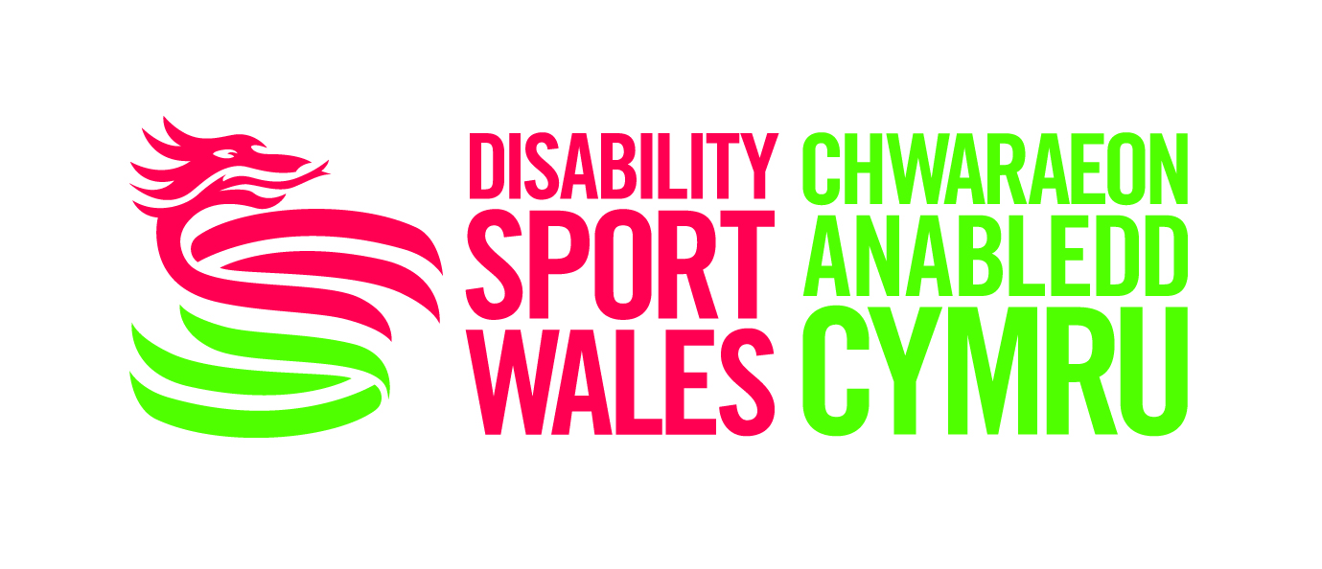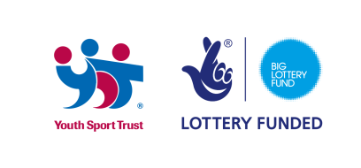

Inclusive Futures Intern

Job Ref: IF-INTERN-2015
Position: Lead your Generation: Inclusive Futures Intern
Responsible to: Disability Sport Wales Inclusive Futures (IF) Co-ordinator
Hosted By: City and County of Swansea
Salary for Internship: £7.85 p/hour (approx £4,000 p.a.) pro-rata
Hours of Work: 12.5 Hours per Week
Length of Internship: 10 Months
DBS Check: Essential

Location: City and County of Swansea, Guildhall, Swansea

We are committed to promoting equality of opportunity for all staff and job applicants. We aim to create a working environment in which all individuals are able to make best use of their skills, free from discrimination or harassment, and in which all decisions are based on merit.

We do not discriminate against staff on the basis of age, disability, gender reassignment, marital or civil partner status, pregnancy or maternity, race, colour, nationality, ethnic or national origin, religion or belief, sex or sexual orientation (protected characteristics).

The Federation of Disability Sport Wales is a national organisation which aims to promote and develop opportunities for disabled people to participate in sport.
VISION
‘To Transform Lives through the Power of Sport’
MISSIONS
- Every Disabled Person Hooked on Sport for Life
- Creating A Nation of Champions

About Inclusive Futures – a project from the Youth Sport Trust

The project is a leadership and volunteering initiative for young people, with the emphasis on inclusion to promote positive attitudes towards young disabled people, increase participation in physical activity, develop inclusive practice and empower young people to deliver activities in their local communities.
The programme aims to generate a step change in behaviour and attitudes amongst young disabled and non-disabled people on issues related to ability, access and equality in sport. The Inclusive Futures intern will support the Inclusive Futures Co-ordinator to collectively aim to help 12,000 young people nationally to access more inclusive opportunities. By engaging these young people as leaders in their communities, we believe that they can challenge the stereotypes surrounding disability, actively showing local service providers the value of youth empowerment and inclusive practice which will help to improve and sustain young people’s participation and involvement in physical activity and sport.”
The Role & Person
- Please refer to the Job Description and Person Specification
Please note; you will need to be able to transport yourself to and from meetings, events and project sites and commit to working to some non-regular unsocial hours as required.
Closing date: 10th March 2015
Informal Interview Date: 23rd March 2015

For more information or an informal chat: Please contact Darren Wyn Jones, Inclusive Futures Co-ordinator 07714 281627 or email darren.jones@swansea.gov.uk Alternatively, visit the news section of the Disability Sport Wales website www.disabilitysportwales.com where information and applications can be downloaded.

