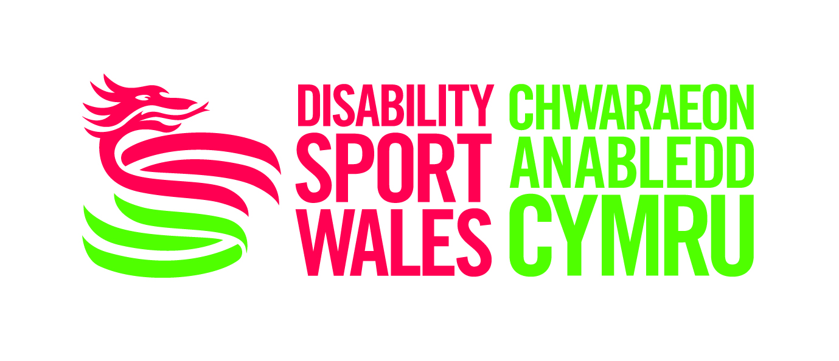  JOB DESCRIPTION  Job Reference: IF-INTERN-2015 | 

Position: Lead your Generation: Inclusive Futures Intern

Responsible to: Disability Sport Wales Inclusive Futures (IF) Co-ordinator

Hosted By: City and County of Swansea

Salary for Internship: £7.85 p/hour (approx £4,000 p.a.) pro-rata

Hours of Work: 12.5 Hours per Week

Length of Internship: 10 Months

DBS Check: Essential

Overall Role:

The Intern will work within Swansea, working with a range of partners including City and County of Swansea, Youth Sport Trust, Disability Sport Wales, community groups, clubs and schools to support the IF Co-ordinator to continue the development of the Lead your Generation: Inclusive Futures programme. The role will support the recruitment of young people, especially young disabled people, to sign-up to the project and volunteer as sports leaders within their community and at selected events. The role will require a strong understanding of the Inclusive Futures project in Swansea and an ability to relate well with young people, particularly young disabled people.

Overall role:

- To liaise with identified schools, colleges, community clubs and other organisations to support the effective delivery of events within the project.

- To support the IF Co-ordinator to collect and submit KPI’s for the project.

- To use appropriate social media to provide latest information to young leaders

- To work with identified schools on the recruitment of young disabled people to be involved with the Inclusive Futures programme.

- Support the delivery of Sports Leaders awards.

Duties & Responsibilities:

Building Relationships
- Work effectively with the project mentors, ambassadors, existing volunteer champions and newly recruited young disabled people.

Teamwork
- Establish excellent relationships with the Swansea AYP Team, Disability Sport Wales and the Inclusive Futures Co-ordinator to ensure effective delivery of the programme.

- Contribute to team learning by sharing knowledge at team meetings.

Planning & Organising
- Support the planning and delivery of local events associated with the programme.

Communication
- Maintain effective communication with those young people involved in the programme.

- Using knowledge of the programme and the needs of young people, contribute to decisions regarding the appropriate format to distribute information to the young people, particularly young disabled people.

PERSON SPECIFICATION Job Ref: DSWIFI001

Applicants for this position should be able to satisfy the following criteria:

Experience |  | Essential | Desirable
 | Strong communication skills with an ability to communicate effectively and confidently to individuals and groups, especially young disabled people | /
 | Experience of working with and alongside others to complete a project. | /
 | Experience of utilising IT packages (Word, Excel & Powerpoint). |  | /
 | Experience of working with young people particularly young disabled people in a range of settings. | /
 | An understanding of both the Inclusive Futures project in Swansea and the needs of young disabled people. |  | /

Personal Qualities

 | Excellent interpersonal and team skills with the ability to communicate with a wide range of people. | /
 | Able to work as part of a team with a positive helpful attitude. | /
 | Enthusiasm and a genuine interest in this area of work, particularly in schools, inclusion and leadership. | /
 | Ability to connect with young disabled people. | /
 | Strong organisational and planning skills. | /
 | Ability to speak Welsh |  | /

