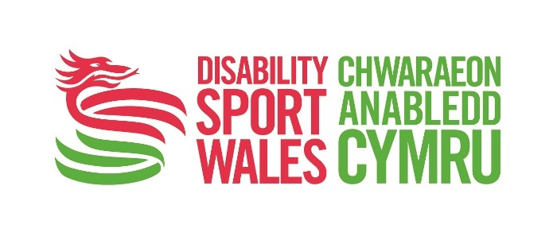
Easy Read

Application form - National Youth Forum

Please tell us information about yourself:
Your name:
Your address:
Your email address:
Your phone number:
Please tick how you would like us to contact you: |  | ☐ | Voice call to telephone
 |  | ☐ | Text to mobile number
 |  | ☐ | Email
 |  | ☐ | Type Talk
 |  | ☐ | In writing
 |  | ☐ | Via a parent/guardian (please provide contact details)

Are you aged 18 or over?

Yes ☐ No ☐

If you have answered No, we will need your parent or guardian to tell us it is ok for you to join the Youth Forum. Please could you fill in the information below.

If you are over 18 there is no need to complete this section.

Name of your guardian
Relationship with your guardian – how do you know them?
Email address
Phone number

Signature of parent or guardian

Please could your guardian sign in the box below to say they are happy for you to apply for the role on the National Youth Forum.

Signature |  | Date

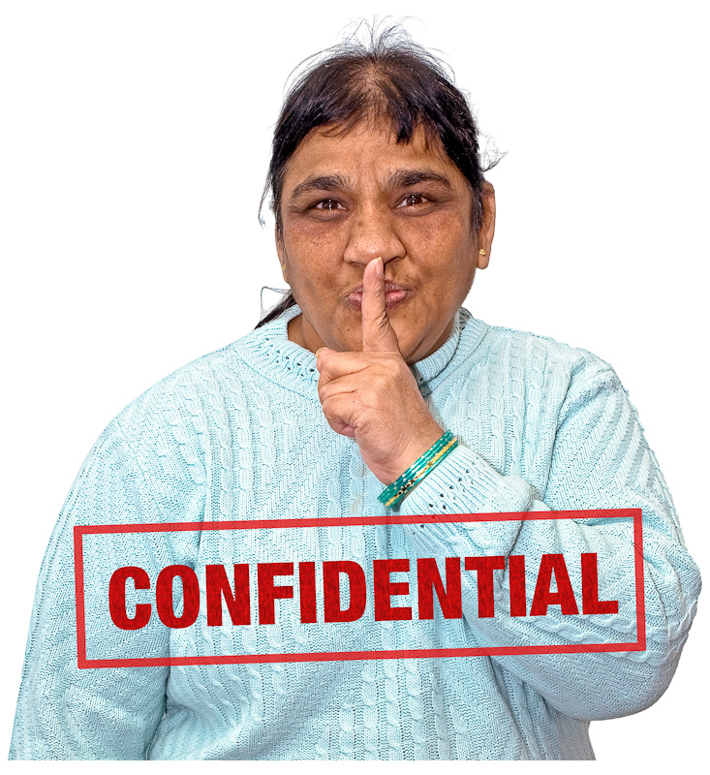

This form is confidential. This means we will keep it private and not show your answers to anyone else.

What council area do you live in? Please tick the area (✓)

Anglesey ☐ Blaenau Gwent ☐

Bridgend ☐ Caerphilly ☐

Cardiff ☐ Carmarthenshire ☐

Ceredigian ☐ Conwy ☐

Denbighshire ☐ Flintshire ☐
Gwynedd ☐ Merthyr Tydfil ☐

Monmouthshire ☐ Neath and Port Talbot ☐

Newport ☐ Pembrokeshire ☐

Powys ☐ Rhondda Cynon Taf ☐

Swansea ☐ Torfaen ☐

Vale of Glamorgan ☐ Wrexham ☐

How did you hear about the national forum? Please Tick (✓)

On a website page ☐ On social media ☐

Someone told me ☐ My Disability Sports Wales Officer ☐

Another forum group ☐ Something else (please say below) ☐

Application form

Disability Sport Wales National Youth Forum

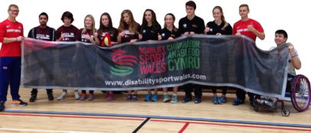
Question 1

Why do you want to join our National Youth Forum?

Question 2

Please tell us more about yourself. Please include things like:


- Your hobbies – what do you like to do in your spare time?

- Are you in education? Tell us about what you are learning.

- Are you in work? What do you do?

- What have you achieved - what have you done that you are proud of?

Question 3

We want to know more about what you are good at and the things you have done. Please include things:
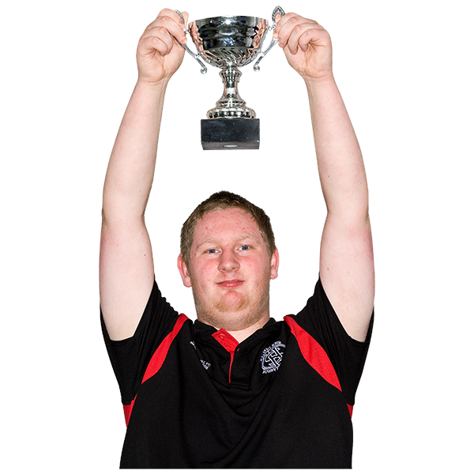
- Any qualifications or certificates you have.

- Your skills – what are you good at?

- If you have experience of working with or knowing disabled people. Or if you have played or watched any disability sport.

- If you have done any volunteering before.

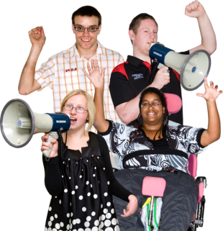
Question 4

Our Youth Forum is an opportunity for young people’s voices to be heard.

What do you think you could do to help this?

Question 5
?

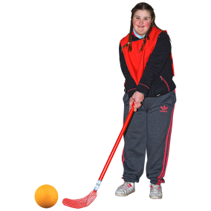
What is the most important thing that needs to change in Wales so more disabled people can take part in sport?

This could be something that helps disabled people play sport, help out as a volunteer, or watch sport.

Please make sure you fill in the Equal Opportunities Form at the end of this document.

Your skills

Please complete the Skills Scorecard on the next page. To be a member of the National Forum we need you to have good skills. This chart helps us to find out what your skills are.

Don’t worry if you can’t fill out one of the boxes. As a member of the Youth Forum we can help you to improve your skills.

How to complete the chart:


I’m really good at this. I know a lot

I’m good at this. I know a little

I’m not good or bad at this. Somewhere in the middle

I’m not good at this. But I have some experience of doing this

I don’t know about this at all. I haven’t done this before.

Skills Scorecard
Skills |  |  |  |  |  | Please give an  example of what you are good at in this area:
Working in a team
Speaking with other people
Sorting out problems
Learning new things and helping other people to learn new things
Taking charge of things
Skills |  |  |  |  |  | Please give an  example of what you are good at in this area:
Experience of chairing groups and meetings
Experience of working with disabled people, or caring for disabled
people
Using social media – like Facebook and Twitter
Speaking in public
Being organised

More information

If you have a question or would like to give a verbal application please contact Darren Wyn Jones, Youth Forum Co-ordinator, Disability Sport Wales:

Phone: 07557554272 (phone or text)

Email: darren.jones@disabilitysportwales.com

Please also send your email to: james.ledger@disabilitysportwales.com

Please return your application form to us by 9th December 2016

By post to:

Disability Sport Wales
Forum Disability Sport Wales
Sport Wales National Centre
Sophia Gardens
Cardiff
CF11 9SW

By email to: darren.jones@disabilitysportwales.com

Please also send your email to: james.ledger@disabilitysportwales.com

Please give enough time for your application to be received.

Please phone us and check that we have received your application.
Important

Please make sure you include all of the following documents with your application:

- Completed Application Form

- Completed Equality Opportunities Form. Please complete this as we want to make sure that we have Youth Forum Members from a wide area of communities.

If you cannot apply by the deadline of Friday 9 December but have a good reason please contact Darren Jones as soon as possible.

Phone: 07557554272 (phone or text)

Email: darren.jones@disabilitysportwales.com

Disability Sport Wales is an equal opportunities employer.

We work hard at making sure we treat equally every job applicant, employee, volunteer or member.

