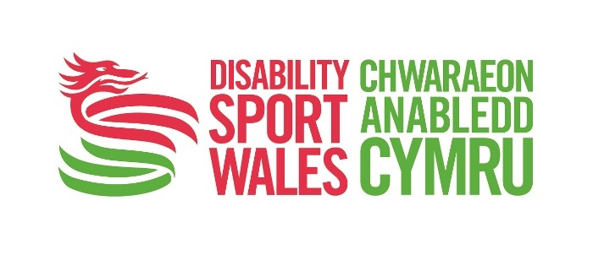
Easy Read

Equal Opportunities form - National Youth Forum

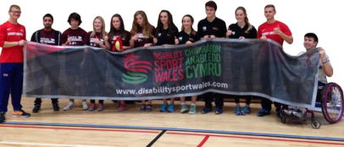
We want to make sure that we have Youth Forum Members from a range of area in Wales.

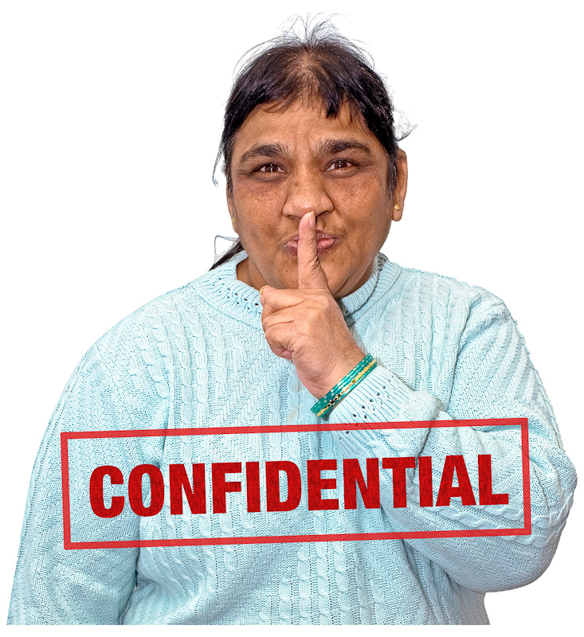
Please complete this form as much as possible.

This form is confidential. This means we will keep it private and not show your answers to anyone else.

- Do you know anyone who works for Disability Sport Wales? For example, friend or family member. Please tick (✓)
☐ | Yes | ☐ | No
If yes, please tell us their name, relationship to you, and their job title

Name: ……………………………………………………………………………

Relationship to you: .…………………………………………………….……..

Their job title: .…………………………………………………………..……….

- Have you ever been convicted of a crime? Please tick (✓)

☐ | Yes | ☐ | No
If yes, please give details of the crime, including the date and the sentence you received:

……………………………………………………………………………………

……………………………………………………………………………………

……………………………………………………………………………………

……………………………………………………………………………………

You are not required to give any information on ‘spent’ convections under the rehabilitation of offenders act 1974 unless the post is exempt. Failure to disclose convictions could result in disciplinary action or dismissal

- Which age group do you belong to?

☐ | 16 - 17 | ☐ | 18 - 21 | ☐ | 22 -24
☐ |  |  |  | ☐
☐ |  |  |  | ☐
☐ |  |  |  | ☐ | I don’t want to say

- How do you describe your national identity?

(Please tick all that are true):

☐ | I am British | ☐ | I am Scottish | ☐ | I am English
☐ | I am Welsh | ☐ | I am Northern Irish | ☐ | I am Irish
☐ | I don’t want to say

- What is your ethnic group?

Choose one section (A to E, or choose F ‘I don’t want to say'), then tick one box to best describe your ethnic group or background.

- White

☐ | Welsh / English / Scottish / Northern Irish / British | ☐ | Gypsy or Irish Traveller
☐ | Irish | ☐ | Any other White background (please say):
…………………………………………….

…………………………………………….

- Mixed / Multiple ethnic group

☐ | White and Black Caribbean | ☐ | White and Asian
☐ | White and Black African | ☐ | Any other Mixed / multiple ethnic background (please say):
…………………………………………….

…………………………………………….

- Asian / Asian British

☐ | Indian | ☐ | Bangladeshi
☐ | Pakistani | ☐ | Chinese
☐ | Any other Asian background (please say): |  | …………………………………………….  …..…………………………………….….

- Black/African/Caribbean/Black British

☐ | African | ☐ | Caribbean
☐ | Any other Black / African / Caribbean background (please say): |  | ……………..………………………….…  ………………………………………..…

- Other ethnic group

☐ | Arab | ☐ | Any other ethnic background (please say):
………………………………………..…

…………………………………………..

- I don’t want to say

☐ | I don’t want to say

- Are you?

☐ | Male | ☐ | Female | ☐ | I don’t want to say

- Is your gender identity different to the sex you were described at birth?

☐ | Yes | If yes, please describe the difference: | ………………………………  ………………………………
☐ | No
☐ | I don’t want to say

- Do you tell people you are a transgender or a trans person?

☐ | Yes | ☐ | No | ☐ | I don’t want to say

- How would you describe your sexual orientation?

☐ | Heterosexual / straight | ☐ | Gay man | ☐ | I don’t want to say
☐ | Gay woman / Lesbian | ☐ | Bisexual
☐ | Other (please tell us how you want to be described): | ………………………………………………………  ……………………………………………………….

- Do you tell people you are disabled?

□ | Yes (go to 10.a) | □ | No (go to 11) | □ | I don’t want to say (go to 11)

10.a How would you describe your disability?

Please mark all the boxes that are true:
☐ | I am blind or partially sighted | ☐ | I am deaf or hard or hearing | ☐ | I am physically disabled but do not use a wheelchair
☐ | I am physically disabled and use a wheelchair | ☐ | I am physically disabled and use a wheelchair sometimes, or for sport | ☐ | I have a learning disability
☐ | I have a learning difficulty | ☐ | I have a mental health problem | ☐ | I have a long-term illness. For example, cancer, multiple sclerosis, HIV+, etc
☐ | Other (please say):  …………………………………………………… |  |  | ☐ | I don’t want to say
- What language do you use?

☐ | English (spoken) | ☐ | Welsh (spoken) | ☐ | Other European Language (spoken)
☐ | Makaton | ☐ | British Sign Language | ☐ | Easy read
☐ | I don’t want to say
☐ | Other (please say):  …………………………………………………………………………………

- If you speak Welsh, how well do you speak it? Please tick all boxes that are true

☐ | I can speak Welsh | ☐ | I can write Welsh | ☐ | I can read Welsh
☐ | I can understand spoken Welsh | ☐ | I can read easy read Welsh | ☐
☐ | I don’t want to say

- What is your religion or belief?

☐ | I don’t have a religion / I am undecided | ☐ | I am Hindu | ☐ | I am Sikh
☐ | I am Christian (including Church or England, Catholic, Protestant and all other Christian denominations) | ☐ | I am Jewish | ☐ | I am Spiritual
☐ | I am Buddhist | ☐ | I am Muslim | ☐ | I have another religion (please say):
☐ | I don’t want to say |  |  |  | ……………………..…  …………………….….
Is there anything Disability Sport Wales may need to know or put in place to make that you are properly supported in your job?
☐ | Yes | ☐ | No
If yes, please give further information:

………………………………………………………………………………..……

………………………………………………………………….…………………

……………………………………………………………………………….……

………………………………………………………………….…………………

…………………………………………………………………………….………

………………………………………………………………….…………………

Please tell us where you found out about this job vacancy:

☐ | Newspaper | ☐ | Disability Sport Wales Website | ☐ | Other Website (please say):  ………………….………………  ………………………………….
☐ | Welsh Sports Association | ☐ | Someone told me | ☐ | Job centre

