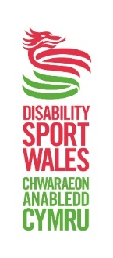
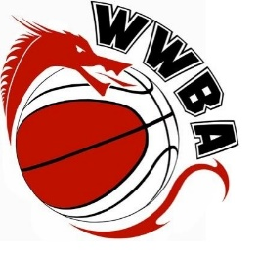

Welsh Wheelchair Basketball Head Coach (x3)

Organisation
Welsh Wheelchair Basketball
Salary
Volunteer basis
Closing date
Monday 13th February 2017

Welsh Wheelchair Basketball are now recruiting for 3 experienced, high quality Head Coaches for the Welsh Under 15, under 19 and under 23 age groups. The Head Coaches are responsible for all field of play management and the selection and training of the regional athletes.

Key Roles and Responsibilities
- To assist in creating a performance environment and culture for athletes and team staff.
- To take responsibility for coaching sessions.
- To maintain high ethical standards in coaching, ensure they keep up-to-date with their knowledge, skills and qualifications and prepare all coaching sessions in advance.
- To undertake training appropriate to the role e.g. child protection training.
- To work with and include assistant coaches in the preparation and running of each session.
- To offer feedback on the organisation and degree of success of coaching and competitions.
- To prepare the selection of team for competition including table registrations and shirt No’s.
- To travel to competitions with the team(s).
- To work in partnership with the Team Managers and team staff within the sport to ensure coherence
- Be young people focussed and able to plan, empathise and communicate effectively with athletes and team staff.
- Have an understanding of the issues affecting children and young people and the sensitive way in which these issues must be managed. These include controlling and managing individual and team behaviour
- Have an understanding and appreciation of the need to respect confidentiality.
- Have effective communication skills, both written and oral including conflict resolution skills.
- Supporting any public relations, communications and media requests as appropriate with team members.
- All athlete communication as appropriate.
- Comply with and enforce relevant codes of conduct

Person Specification

- Excellent knowledge level of Basketball or wheelchair basketball
- The applicant will be required to hold a Grade 2 coaching certificate
- A basic knowledge of BWB & IWBA rules and regulations.
- Have experience of coaching young people and junior teams, ideally within one of the British Wheelchair Basketball Leagues and/or competitions.
- Be young people focussed and able to plan, empathise and communicate effectively with athletes and team staff.
- Have an understanding of the issues affecting children and young people and the sensitive way in which these issues must be managed. These include controlling and managing individual and team behaviour, enforcing the school games codes of conduct and welfare plan.
- Have an understanding and appreciation of the need to respect confidentiality.
- Have effective communication skills, both written and oral including conflict resolution skills.
- Understand the ‘performance environment’ required for an athlete.
- Complete and produce a satisfactory enhanced DBS Check with Barred List Check prior to commencement of employment.

This position is a voluntary role and would involve some evening and weekend working due to the
nature of the role.

How to apply
To apply for this role please send your Equal Opportunities form, CV and a covering letter outlining why you are suitable for this role to s.jones@britishwheelchairbasketball.co.uk or for more information please call Shelley Jones 07943 098868.

