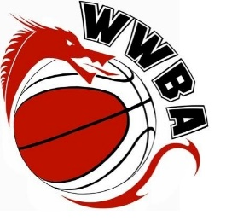
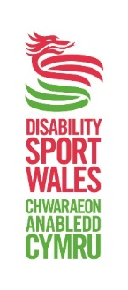

Welsh Wheelchair Basketball Team Manager (x3)

Organisation
Welsh Wheelchair Basketball
Salary
Volunteer basis
Closing date
Monday 13th February 2017

Welsh Wheelchair Basketball are looking to appoint a 3 team managers to support the under 15, under 19 and under 23 National Teams.

The Team Manager is the key point of contact for the athlete. He/she will be responsible for all “non field of play” areas and the flow of communication between the Wales Wheelchair Basketball (WWB) lead, the Coach and the athlete.

Overall Responsibility:
- To assist in creating a performance environment and culture for athletes and team staff
- To manage and co-ordinate all team requirements
- Organisation of team selection and training dates, venues etc to be communicated with WWB.
- Athlete and team staff kit ordering and distribution.
- To be the liaison point between the NGB and the athlete
- To work in partnership with WWB to ensure the welfare of athletes and team staff
- To work in partnership with other Team Managers and team staff within the sport to ensure coherence between individual team and plans.
- Confirm selections, eligibility and availability of all athletes, and communicate team selections to the athlete and to WWB/BWB.
- Working with WWB/BWB to provide support with any event admin required and media
requirements.
- Ensuring all athlete information (personal details, kit sizing, medical and welfare information) is completed by team members
- Liaise with the nominated transport provider to support the planning of all team travel arrangements: to and from competition
- Supporting any public relations, communications and media requests as appropriate with team members.
- To comply with and enforce relevant codes of conduct.

Person Specification:
- Have experience of managing young people and sports teams.
- Be young people focussed and able to plan, empathise and communicate effectively with athletes, team staff, volunteers and WWB
- Have an understanding of the issues affecting children and young people and the sensitive way in which these issues must be managed. These include controlling and managing individual and team behaviour, enforcing the codes of conduct.
- Have an understanding and appreciation of the need to respect confidentiality.
- Have effective communication skills, both written and oral including conflict resolution skills.
- Understand the ‘performance environment’ required for an athlete.
- Complete and produce a satisfactory enhanced DBS Check with Barred List Check prior to commencement of employment.

This position is a voluntary role and would involve some evening and weekend working due to the
nature of the role.

How to apply
To apply for this role please send your Equal Opportunities form, CV and a covering letter outlining why you are suitable for this role to s.jones@britishwheelchairbasketball.co.uk or for more information please contact Shelley Jones, 07943 098868.

